MEDICAL CERTIFICATE

SIGNATURE OF PATIENT OR THUMB IMPRESSION_________________________

I Dr. _________________after personal careful examination of the case certify hereby that Mr/Mrs/Ms ______________________ whose signature is given above is suffering from_______________________ and I consider that a period of absence from duty of ______ days with effect from ______________to_____________ is absolutely necessary for the restoration of his/her health .

I,Dr. __________________after careful examination of the case certify hereby that Mr/Mrs/Ms ________________ on the restoration of health is now fit to join service .

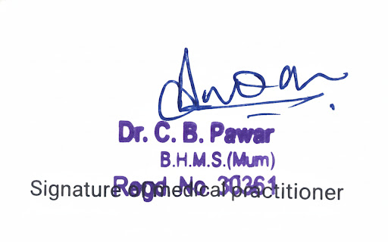
Place ___________
Date ____________ Registration No. __________

(Medical Council of India / State Medical Council of ______________ State)

